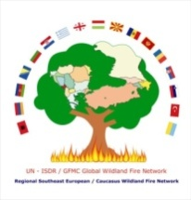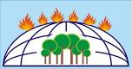
Regional Fire Monitorig Center Global Fire Monitoring Center European Centre on Forest Fires
(RFMC) (GFMC) (ECCF)

Workshop “Development of Guidelines for the Defense of Rural Populations, Settlements and other Assets Against Wildfires and Smoke Pollution”
8 - 10 November 2012
Skopje, Macedonia

AGENDA
Thursday, 8 November 2012
in the afternoon | Arrival of participants
19:00 – 21:00 | Joint dinner
Friday, 9 November 2012
09:30 – 09:40 | Official opening of the workshop
09:40 – 12:00  Nikola | An review of situation with forest fires in the countries of the participants, in terms of the topic of guidelines  (10 – 15 min per participant)
12:00 – 12:30 | Coffee break
12:30 – 13:45  Ioannis/Gavril | Review and Discussions of the sections of the guidelines:  SECTION 1 – BACKGROUND  SECTION 2 – FIRE BASICS AND AWARENESS
13:45 – 15:15 | Lunch
15:15 – 16:45  Ertugrul | Review and Discussions of the sections of the guidelines:  SECTION 3 – PREPARE, DEFEND, SURVIVE  SECTION 4 – PROTECTING VILLAGES AND FARMS
16:45 – 17:15 | Coffee break
17:15 – 18:45  Johann | Review and Discussions of the sections of the guidelines:  SECTION 5 – GUIDELINES FOR LOCAL POPULATION  SECTION 6 – Smoke and Other Secondary Threats from Wildland Fires: Guidelines for Protecting Community Health and Security  ANNEXES  -Conclusions
20:00 | Official dinner
Saturday, 10 November 2012
In the morning | Departure of participants

