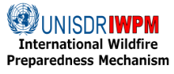 | 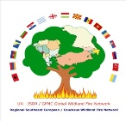 | 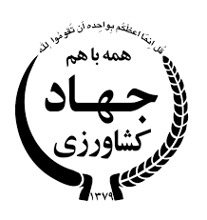 | 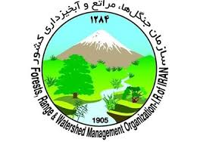 | 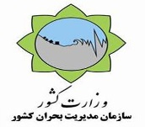 | 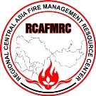 |   Global Wildland Fire Network

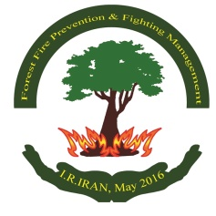
First International Fire Management Week, Islamic Republic of Iran

National Round Table on Fire Management
Training Course on Integrated Fire Management

Mazandaran, Kelarabad, Islamic Republic of Iran, 9-12 May 2016

Agenda

Monday, 09 May 2016

Day 1: National Round Table on Fire Management

9:00-10:30 Session I: Welcoming and Opening Remarks

- Natural Resources Protection Guard (office in charge of fire control) (10 min)
- Director, Global Fire Monitoring Center (GFMC) on behalf of the Global Wildland Fire Network (GWFN) and the International Wildfire Preparedness Mechanism (IWPM) (10 min)
- Mazandaran Province Governorate (10 min)
- Head, National Crisis Management Organization (NDMO) (10 min)
- Division for Natural Environment and Biodiversity, Department of Environment (DOE) (10 min)
- UN Representative in IR Iran (10 min)
- Head, Forest, Rangeland and Watershed Management (FRWO) (10 min)

10:30-11:00 Coffee break

11:00-12:30 Session II: Regional Wildfire Challenges

- Wildfire threats and fire management in IR Iran (FRWO) (20 min)
- Wildfire challenges in the Western Balkans (RFMC) (20 min)
- Wildfire threats and fire management in the South Caucasus (GFMC) (20 min)
- Wildfire problems and fire management in Central Asia (RCAFMRC) (20 min)

- Discussion

12:30-14:00 Lunch break

14:00-15:30 Session III: Fire Management Policy

Fire management national analysis / assessment
- Global and regional examples (GFMC) (10 min)
- National example: Mongolia 2015 (RCAFMRC) (10 min)

Interagency cooperation
- Examples from the South Caucasus (GFMC) (10 min)
- National example: Mongolia 2012-2016 (RCAFMRC) (10 min)

Fire management policy
- General principles for consideration (GFMC) (150 min)
International Cooperation
- Legal agreements and voluntary cooperation (GFMC) (15 min)

Discussion: Relevance for IR Iran
15:30-16:00 Coffee break

16:00-17:00 Session IV: Fire Management Principles

Use of prescribed fire in forestry and conservation
- Examples from temperate-boreal Eurasia (GFMC) (10 min)

Management of dangerous fires burning on terrain contaminated by unexploded ordnance and land mines
- National example: Germany (GFMC) (10 min)

Role of Volunteers
    - National example: Macedonia (RFMC) (10 min)

Guidelines for the Defence of Local Communities
- National example of application: Mongolia (RCAFMRC) (10 min)

Fire, human health and human security
- Examples from Eurasia and SE Asia (GFMC) (10 min)

Wildland fire early warning
- Global and regional early warning systems (GFMC) (5 min)
- National example: Fire Danger Rating in Macedonia (RFMC) (5 min)

Discussion: Relevance for IR Iran

17:00-18:30 Session V: Round Table and Formulation of National Concerted Action

Discussion topics
- Formulation of a proposal for the establishment of a National Committee on Fire Management or a National Action Plan
- Priorities to be addressed by the committee / action plan

18:30 -19:00 Closing Session (with participation of the media)

- Declaration of the National Meeting
- Interviews with the Media (FRWO)

Tuesday, 10 May 2016

Day 2: Fire Management Training Course – Basics

08:00 Registration of Participants

09:00-09:30 Opening of the Seminar
- Welcome remarks by the host (FRWO)
- Welcome remarks by the GWFN / IWPM (GFMC)

09:30-11:00 Presentations (I)

- Wildfire threats and fire management in IR Iran (FRWO) (15 min)
- Wildfire challenges in the Western Balkans (RFMC) (15 min)
- Wildfire threats and fire management in the South Caucasus (GFMC) (15 min)
- Wildfire problems and fire management in Central Asia (RCAFMRC) (15 min)

- Principles of effective communication in fire management training (RFMC) (20 min)

11:00-11:30 Coffee break

11:30-13:00 Presentations (II)
- Introduction to EuroFire Standards: Background (GFMC) (15 min)
- Introduction of the EuroFire Standards and Training Materials in Farsi (FRWO) (15 min)
- EuroFire Training Standards and Materials – Fundamental Fire Behaviour and Tactics (RCAFMRC) (60 min)

13:00-14:00 Lunch break

14:00-15:30 Presentations (III)
- EuroFire Training Standards and Materials – Hand Tools (RFMC) (45 min)
- EuroFire Training Standards and Materials – Fire Safety (RFMC) (45 min)

15:30-16:00 Coffee break

16:00-17:00 Presentations (IV)
- EuroFire Training Standards and Materials – Ignition (GFMC) (45 min)
- Discussion

Wednesday, 11 May 2016
Day 3 -Fire Management Training Course – Exchange of Knowledge, Experience and Skills

09:00-10:30 Presentations (I)
- Training of Volunteers: National example Macedonia (RFMC) (15 min)
- Training of local communities using the Guidelines for the Defence of Villages, Farms and Other Rural Assets against Wildfires for Rural Populations, Local Communities and Municipality Leaders: Introduction (GFMC) (10 min) and national application in Mongolia (RCAFMRC) (15 min)
- Discussion

10:30-11:00 Coffee break

11:00-12:30 Presentations (II)

- Examples of projects implemented in the field of fire management in Iran (FRWO)
- Example of a maneuver program implemented in Iran (FRWO)
- Discussion

12:30-14:00 Lunch break

17:00- 20:00 Visit of the Recreation Areas near Kelarabad and Chalus

Thursday, 12 May 2016

Day 4: Field Demonstration and Exercise

- Briefing of participants
- Departure to the exercise site
- Exercise
- Mopping up
- Evaluation
- Return to training venue

